

**Nagoya Institute of Technology**

**Sato Laboratory**

**EFREI**

2011 - 2012

**General Specifications Document**

**Natural user interface - Kinect**

**LUCCIN Karim – LUONG Kevin**

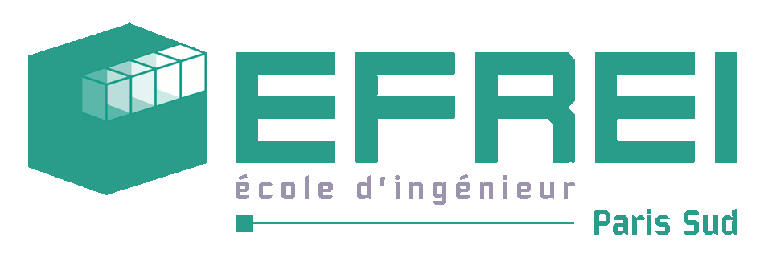

Summary

I. Introduction 4

1. Purpose of the document 4

2. Glossary 4

II. Natural User Interface 5

1. Purpose of the project 5

2. Global description of the system 5

3. Composition of the system 5

4. How the system will work 6

a. User interface 6

b. Movement recognition 6

III. Planning 7

1. Calendar 7

2. Gantt chart 9

IV. Requirements 10

1. Environment 10

2. Demonstration 10

3. Conception 10

4. Implementation 10

V. Quality assurance 11

1. Development method 11

a. Planning of the project 11

b. Analysis 11

c. Conception 11

d. Implementation 12

e. Tests 12

f. Final check 12

2. Control 12

a. Meetings 12

b. Bug tracking 13

c. Project report 13

3. Quality check 13

# Introduction

## Purpose of the document

The purpose of this document is to present our project with Kinect: Implementation of a Natural user interface. This document will present in details the environment and what we will do in the project.

## Glossary

*SDK*: “Software Development Kit” set of programs and libraries to help develop applications.

*Kinect*: Microsoft camera used to capture gestures done by the user.

*User interface*: Visible part of the program for the user where he can interact with the application.

*Metro design*: Design for user interface which is appropriate for touch devices (large buttons, wide text…).

# Natural User Interface

## Purpose of the project

The goal of this project is to develop a natural user interface with Kinect. This means that the user will be able to interact with the computer via hand/arm motions.

The Kinect program will be developed with the Kinect SDK that came out last April.

For this project we will also develop a web browser based on the design of Internet Explorer 10. This browser will be specifically adapted to Kinect using a Metro style. At the end the web browser will be able to understand the various input devices such as Kinect, the mouse and the keyboard.

## Global description of the system

The system will be composed of 3 parts:

* Data acquisition: the system will be able to acquire data from the Kinect, the mouse and the keyboard
* Movement recognition: the system will have to recognize and understand the various gestures done via the Kinect. The gestures recognized will be analyzed using a database built with learning algorithms.
* User interface: a metro style UI will be developed to let the user interact with the Kinect.

## Composition of the system

User interface :

Metro style

Input devices :

Kinect, mouse, Keyboard

## How the system will work

### User interface

The user will have to first initialize the system. When it is done he will arrive in the front page of the program where he will choose to launch: a web browser, his mail account or the desktop.

The user will choose the different options using the Kinect or the mouse. By doing gestures the system will recognize and interpret them. From this application the user could zoom in/out, click, and move the page up or down…

### Movement recognition

From the data acquisition done via the Kinect, our system will have to analyze and recognize the gestures. From a database containing different patterns, the system will have to match the gestures the user has done with the patterns.

Each gesture will be composed of successive simple movements. If a complex gesture is done by the user, for example moving his hand right and up then the system will recognize first the movement “going right” and then the movement “going up”. The purpose of this solution is to simplify every gesture done by the user: these movements are independent from the time and the distance. So it will not matter if the user has done a very slow gesture or a very small one.

# Planning

## Calendar

Planning of the project: 2 weeks

* Define the project
  + Purpose of the project
  + Use cases
* Gantt chart
* Launch

Analysis: 5 weeks

* Data gathering of the various tools (camera/Kinect)
* Learning programming languages (Xaml, C#)
* Do prototypes to see feasibility and to see how it works
* Define functional and technical specifications
* Put priority on specifications

Conception: 3 weeks

* Conceive architecture of the system
* Conceive and integrate the database
* Conceive prototypes of the user interface
* Conceive prototypes of the system interface

Implementation: 13 weeks

* Data acquisition
  + Data gathering from Kinect
  + Data gathering from mouse/Keyboard
  + Data gathering from vocal
* Movement recognition + database management
  + Algorithm for the movement recognition + implementation
* User interface
  + Web browser
  + Mail
  + Photo/video
  + Vocal data management
* Integration

Tests: 2 weeks

* Functional tests

Final check: 1 week

* Check documents
* Clean code

## C:\Users\Kevin\Documents\Projet Japon\Gantt.pngGantt chart

# Requirements

## Environment

The Kinect must be connected to the computer. The user must be at least 2 meters away from the Kinect.

## Demonstration

For the presentation of our system, the Kinect must be connected to the computer. Then the user will execute the application. From this point on he will be using the program by doing gestures, using the mouse/keyboard, or using vocal commands.

## Conception

The application done for this system will be object oriented.

We will use UML language to draw the different diagrams as it is well known by most developers.

## Implementation

The core system will be developed in C# on Windows 7 since the Kinect makes use of the Windows environment. We will also be using the Kinect SDK released earlier as it offers many libraries to work with the Kinect. For the user interface it will be developed in Xaml and C#.

The database used for this project will be MySQL.

We will use Git for our versioning as it will improve our organization. Moreover this versioning system is not centralized: each user keeps in locale the modifications they have done on the project; so each user can work on different branch of the project.

# Quality assurance

The system will must be of quality to satisfy the user. We will especially focus on the aesthetic of the user interface. It has to be both easy to use and visually attractive.

## Development method

The method used for this project is Agile. The main advantage of this method is to work by iterations. We first begin by working on the core of the system which has the least possibility of being modified through the project. At the end of iteration a meeting will be done to validate the solutions found.

The project is divided into 7 parts:

### Planning of the project

During this phase we first think of the functionalities offered by our system. By doing so we can then establish a Gantt chart and estimate the time needed for the development.

### Analysis

As it is a new technology to us we will have to study how the Kinect works and learn some new programming languages. During this phase we will also define the general and technical specifications that we will develop later.

The purpose of this phase is also to see the feasibility of the project by developing some prototypes or proof of concept.

### Conception

For this we will focus on the architecture of the system. From the prototypes done earlier we can see the different modules composing our system. We will use UML to draw the various diagrams such as class diagram, database diagram…

During this conception phase we will also sketch some rough screens of the user interface.

### Implementation

Now that we have decided the architecture of the system we will now implement the solution.

For the implementation phase it will be divided into 3 sprints:

* The first sprint will be on the data acquisition. By the end of this sprint we will have a functional module for gathering data from the input devices.
* The second sprint will focus on the algorithm of the movement recognition and some screens of the user interface. At the end of the sprint we will have some rough screens of the final user interface. By the end of this sprint each of us will work separately, one person will be in charge of the implementation of the movement recognition algorithm while the other will be working on the user interface.
* The last sprint will be the final version of our system. Everything should be implemented and functional at the end of the sprint.

### Tests

For this phase we will test every functions of our system. The purpose is to make sure that there is no bugs anymore and that the project is fully working.

### Final check

In this last phase we check the documents that we have written for the project, clean the code, check that the application is fully functional…

## Control

### Meetings

A weekly meeting with our teacher is done to see how the project is progressing. This meeting is also used to talk about the difficulties encountered in the project.

At the end of each phase/sprint, a little presentation is done to show what has been done so far.

### Bug tracking

Every bug encountered in this project will be written down as “not solved” with a small description of the bug and kept in an Excel file. If someone is working on a specific bug he has to leave his name next to the bug and change the bug’s status to “testing” so the team won’t try to solve the same bug. Once the person finds a solution he will have to write down the solution and finally update the status to “solved”.

### Project report

Each week a meeting is done to see how the project is progressing and what is left to be done for the next weeks. From these meetings, the project report is slowly done; the goal is to have most of the project report done by the end of the project.

## Quality check

|  |  |  |  |
| --- | --- | --- | --- |
| Iteration | Activity | Quality check | On… |
| Analysis | Analysis of the requirements | Document review | GRS |
| Sprint 1 | Whole iteration | Project review | Release Definition |
| Development | Code review | Code |
| Tests | Test review | Sprint Test List |
| Sprint 2 | Whole iteration | Project review | Release Definition |
| Development | Code review | Code |
| Tests | Test review | Sprint Test List |
| Sprint 3 | Functional tests | Test review | Project Report |
| Whole iteration | Project review | Project Report |
| System | Code review | Code |